UNIVERSITAT POLITÈCNICA DE CATALUNYA
FACULTAT D'INFORMÀTICA DE BARCELONA
Official Master in Data Science


________________________________________________________________
Predicting the Genre of a Spotify Song:
A machine Learning Approach
________________________________________________________________

Alexandros Tremopoulos
Andreja Andrejic
Victor Gonzalez Monge

Barcelona, 2024

1. Introduction 3
2. Related previous work 3
3. Data exploration process 3
3.1. Exploratory data analysis 3
3.2. Missing values 4
3.3. Duplicated observations 4
3.4 Outlier detection 4
3.5 Derivation of new variables: Feature extraction 5
3.6 Feature selection 5
3.7 Transformations, Normalization and Gaussianity 6
3.8 Imbalance 7
3.9 PCA and Clustering 7
4. Modeling methods 8
4.1 Validation protocol 8
4.2 Evaluation metrics 9
4.3 Gaussian Naive Bayes 9
4.4 Logistic Regression 9
4.5 Linear Discriminant Analysis - LDA 10
4.6 Quadratic Discriminant Analysis - QDA 11
4.7 Κ-Nearest neighbors - KNN 11
4.8 Decision Trees 12
4.9 Random Forest 13
4.10 Extra Trees 13
4.11 Support Vector Machines 14
4.12 Multi-layer Perceptron 15
4.13 Voting-Stacking 16
5. Results obtained 16
6. Final selected model 17
7. Scientific and personal conclusions 17
8. Possible extensions and known limitations 18
Appendix 19
References 30

1. Introduction
Spotify is one of the largest music streaming platforms in the world, with more songs being added constantly. Due to the amount of these songs, an automated process for classification of possible genres of the song automatically could help reduce the workload of the employees and give the users a better experience.

In this project we aim to train a model with a Spotify dataset capable of correctly classifying possible genres of a song given some data. (All figures in Appendix)

2. Related previous work
There are other online users that have tried to classify the genre of songs with different algorithms, they either obtained poor results or decided to group the different classes, reducing the information the model provides.
For this project we decided to focus on improving the different models without grouping the target to not reduce the information given to the user.

3. Data exploration process
Note that in all our work we use a specific seed being 6046, so the results are reproducible. Also we use some functions provided from labs with some alterations.

3.1. Exploratory data analysis
Initially we explored the dataset to inspect it and familiarize ourselves with it. We checked its shape, the data type of each column, the distribution of each variable and checked some information about their values, like the maximum and minimum values (Figure 1). Ηere we explain some of the features in our dataset:
- Key is the main tone of the song. There are 12 total (A, A#/Bb, B, C, C#/Db, D, …) .
- Mode indicates the modality (major or minor) of a track, the type of scale from which its melodic content is derived. Major is represented by 1 and minor is 0.
- Valence describes the musical positivity of a song; the higher values mean a more positive sound (happy, cheerful)
- Time Signature is the number of beats in a bar (1/4, 2/4, 4/4, 5/4).
- Type has the value ‘audio_features’ in every row, so it is removed from future analysis.
- Liveness detects the presence of an audience in the recording. Higher liveness values represent an increased probability that the track was performed live.
Since genre is our selected target, i.e. we are trying to predict the genre of the song, we check the distribution of its possible values. In Figure 1, we see the distribution and what seems interesting is that Dark Trap and Underground Rap are overrepresented while Pop is very underrepresented. We also plotted histograms for the numerical values.
Looking at the distribution histograms of each feature, we see that the columns instrumentalness, speechiness, acousticness and liveness had somewhat peculiar plots. The other columns do not have any notable patterns.

Instrumentalness predicts whether a track contains no vocals. The closer the instrumentalness value is to 1.0, the greater likelihood the track contains no vocal content. Values above 0.5 are intended to represent instrumental tracks, but confidence is higher as the value approaches 1.0. (Figure 2) Since most of the tracks are vocal, the data points are heavily concentrated around 0-0,05. If we look at the data above 0.05, we get a clearer image of the predictions above this threshold. (Figure 3). Speechiness, acousticness and liveness had a similar plot like instrumentalness, but they are heavily skewed to the left even when the minimum threshold is raised. (Figures 4, 5 and 6)

3.2. Missing values
There are not many missing fields in the dataset. There are only three columns with missing data: Columns Unnamed: 0, title and song_name. The first two coincide, i.e. they have missing values in exactly the same rows. Another peculiarity is that in rows where these two columns have a non-null value, the song_name is missing and vice versa. There are 6 row exceptions which have both title and song_name defined. These rows are removed and title and song_name columns will be combined into the title column.

3.3. Duplicated observations
We observed by seeing the distribution values of the 'id' column that there are some observations with all their values duplicated. More specifically there are thousands of rows having the same values in all their features except the feature 'title'. The ‘title' column has almost the same value with some alterations in the string value. Thus, we consider these duplicated lines not needed and we keep only the first observation of the duplicates that have the same values in all columns except 'title'. More than 3200 observations were dropped. However there are more rows that have duplicated ids. It could mean that the same song belongs to more than one genre. There are almost 3 thousand rows with duplicate values in all features except genre. Though, we decided to keep those rows, because a song could belong in various genres.

3.4 Outlier detection
Firstly, we checked the univariate outliers for each column and then multivariate outliers as well. In univariate outlier analysis, we found a few features containing outliers, but the vast majority of them were mild outliers.
Speechiness, acousticness and liveness are mostly grouped near zero values. Therefore values near the opposite side of the spectrum (around 1) are considered mild outliers. These values are valuable and are left as they were (Figures 4, 5 and 6).
Danceability has a small group (~100) of mild outliers around the 0.1 mark. This is again valuable information and is kept in the dataset (Figure 7).
Loudness has a few ( ~3) severe outliers below the value of -27. These could be removed, but as univariate outliers in our dataset of 13 features, they should not cause problems and are therefore kept (Figure 8).

For multivariate outlier detection, we used Mahalanobis distance. Using this metric, a confidence interval of 95% is calculated according to the Chi-Squared distribution and any instance outside the interval is considered a multivariate outlier. Looking at the plot of 2 random features, we can see that there are no multivariate outliers in our dataset (Figure 9).

3.5 Derivation of new variables: Feature extraction
In this section we are deriving new variables by combining other already existing ones. We create the vocal density column which is derived from speechiness and detects the presence of spoken words in a track and instrumentalness which is related to whether a track contains no vocals (we convert it to tracks containing vocals). So, vocal_density = 1 - (instrumentalness + speechiness). We also create the vocal expression feature which represents the emotional expression conveyed through vocals, by combining speechiness and valence (vocal_expression = speechiness * valence).

3.6 Feature selection
Some columns of our dataset are not useful for us, as well as some others that might not be important for our genre target. We are exploring our features and removing some of them. We observed that there are some titles more than once and up to hundreds. We check some of them and we see that they also share the genre feature but they differ in all other columns. This with the combination of the titles make us think that they are playlists. Either way, we decide to drop string columns like id, uri, track_href, analysis_url and title, because they do not offer any help in predicting genre value.

We used feature selection algorithms to measure the importance of the features which only deal with numerical features.
- Mutual information (MI) :
It measures the dependence of one variable to another by quantifying the amount of information obtained about one feature, through the other feature. MI is symmetric and non-negative, and is zero if and only if the input and output features are independent. It can capture non-linear relationships between input and output features.This algorithm finds mode, time_signature and key to not be important for the genre target (Figure 10). However since they are not numerical columns, the algorithm might not understand their patterns. So, the most important features are tempo, duration_ms, instrumentalness and vocal_density, while all the others are considered somewhat important.

- ExtraTrees:
Extra Trees Classifier is a form of ensemble learning technique that integrates the classification outcomes from various decision trees, which are then gathered in a forest. Feature selection is used to determine the degree of relationship between independent features and dependent features (Figure 11). The results here are not that different. Again time_signature, mode and key are in the bottom 3, but they are considered more important than Mutual Information considers them (especially key). The features deemed more important are similar to the ones given by MI, with tempo, duration_ms and instrumentalness being on the top. The difference is that the importance of vocal_density dropped.

Next we are checking the correlation between all features (Figure 12) Some that are highly correlated among them perhaps should not be kept due to redundant information. There is high correlation with the new extracted features. For example, vocal_density has a negative correlation with instrumentalness of -0.94 and vocal_expression has a positive correlation with speechiness (0.81) and valence (0.61). This makes perfect sense, since these values combination created the others. As it can be seen in the importance results mentioned, although they are important, they are below some of the features that created them. For example, instrumentalness is more important than vocal_density in both algorithms and valence is more important than vocal_expression only in ExtraTrees while in Mutual Information, vocal_expression is more important than valence and speechiness. For now, we will keep these features and test later in a machine learning algorithm if they help our model learn better patterns. We also plot histograms for every feature to see its values distributions along genres. Seeing the hist plots for mode (Figure 13) and time_signature (Figure 14) along with the previous findings make us think that they are not helpful, thus we drop them.

3.7 Transformations, Normalization and Gaussianity
A big difference in the range scale of the variables can cause different problems, like some variables being assigned more importance just because they present a bigger range. To solve this, we analyzed the range of the present features. In the boxplot (Figure 15) it can be clearly seen that our data shows clear differences in the range scale, so we proceeded to apply a minmax operation and observe how the data behaves. The results of the boxplot after the transformation show that the variables now are within the same range (Figure 16).

Gaussianity was also tested before and after the transformation,but due to the nature of the transformation the distribution did not improve, the data does approximate gaussianity for some of the features, but it does not reach it, as can be seen in the distribution plot (Fig 17).
We also thought it would be interesting to see how the numerical variables would behave after transforming them into categorical data and plotting the class distribution of the genre variable for each categorical feature (Figure 18).
To avoid introducing any bias in our test data, we use MinMaxScaler after splitting the data.

3.8 Imbalance
As mentioned above, there are some genres more represented and others less. Thus, we have an imbalanced dataset. We tried a few methods in order to deal with this imbalance. Initially, before any technique is applied we created a baseline with Gaussian Naive Bayes, to be able to compare metrics (e.g. F1 score) in every technique tried afterwards. In this baseline the F1 average in all labels in the validation set is 52.55%. These are the methods tried:
- Pop genre: First thing we tried was to remove all observations that had Pop genre as
a label, since it had around 400 observations and all other labels had more than 1500. This has, of course, helped the model, since we are processing the data in one less class, in which the performance was pretty bad and below average (20.40%). Now the F1_avg is 54.91%. This change is kept for all further analysis.
- Oversampling: Then, we tried an oversampling technique, SMOTE. It is an
oversampling technique where the synthetic samples are generated for the minority class. The result of this was to have 2590 rows referring to each one of the labels. It is interesting that SMOTE decreased the performance dropping it to 53.65%. The performance in almost all classes decreased, but especially in the Underground Rap genre.
- Undersampling:Next, we tried undersampling with the NearMiss algorithm. It
selects samples from the majority class that are closest to the minority class, reducing the overlap between the two classes. Using this made each class to have 719 observations with an F1_Avg of 50.88%. This is a significant drop from our baseline, but that makes sense since the total number of samples is majorly decreased.
- Split Underground Rap: Underground Rap is the class with almost 6000
observations. Besides Dark Trap, these are more than double the observations of every other class. Thus, we thought of splitting it into two classes. We did that by finding the mean of its Underground Rap song’s ‘duration_ms’ and split it into two classes, one with the upper duration half and one with the lower. The F1_Avg was 53.81%, which means it did not help, even though we now had an extra class.

3.9 PCA and Clustering
Clustering was done at the end After we have trained and tried a multitude of classification techniques, our F1 score was plateauing around 66%. In order to better understand the results we were getting, we conducted PCA and K-means clustering on the dataset.
In the plot of all genres on the first two principal components, we see that all genres are clustered around the center of the plot, with some overlapping more and others less. (Figure 19) Then we ran our best model at the time - Random Forest and printed the confusion matrix to see the groups of classes which create the most and least confusion. We analyzed a few groups (and pairs) of interest and show the plots in the first and second as well as first and third principal component:
- Emo, trance and RnB are intuitively very different genres, and the confusion matrix
backs that up with only a few instances being confused with each other. In the plot (Figure 20) we can see that trance is separated from the other two, but emo and RnB do not show the expected separation, rather they are mostly overlapping, especially on the second principal axis. This behaviour is something that is repeated with different genres and is the reason why we cannot improve our results further without losing information. If the size of the dataset was larger, neural networks could possibly have a better chance to catch the intricate relationships of the data.
- Dark Trap and Underground Rap are the classes with the most mutual
misclassification. The plot (Figure 21) depicts visible separation in the two classes mostly on the first and less on the third principal axis. Comparing them with emo and RnB in the previous plot, they have similar patterns of overlapping. The reason for a higher rate of misclassification here is probably because Dark Trap and Underground Rap have almost twice the average number of samples per class. The models we are using are most likely compensating for the lack of samples in other classes and are therefore scoring lower on these classes. This is further supported when we see that Underground Rap, the most represented class, had the best F1 score on the QDA model, which scored the worst overall of all the models tested.
- Trap Metal and Hiphop are the opposite peculiarity in our analysis. The plot (Figure
22) shows extreme overlapping in the first three principal components, but their mutual confusion is very low. This means that the models are discerning them well, despite their overlapping in the feature space as well as intuitive similarity
- Rap, dnb (drum and bass) are an example of expected behaviour. They show zero
confusion and barely any overlapping in the principal axes (Figure 23).

Finally, k-means clustering was conducted on the first five principal components and the resulting clusters are shown in (Figure 24). We chose k=4, as it gave us the clearest clusters, mostly in the first three component axes. Although the clusters are well defined, they do not match any of our target classes and nothing much can be deduced from it.

4. Modeling methods

4.1 Validation protocol
To evaluate the performance of the models, we initially split the data into train and test with a 67% - 33% split. Then, the train data is again split into train and validation samples, with a 67% - 33% split once again. So, we end up with 3 sets, train (44.88%), validation (22.10%) and testing (33%) sets with a total of 37667 observations. In both splits, we split by stratifying around our target column - genre. After the first and before the second split we also scale the data with the MinMaxScaler and then apply it to the test set. The test set will remain untouched until the end of all our modeling and will be used only for grading our final selected model.
For every machine learning algorithm we perform a grid search for its hyperparameters. We do that on the training set with 5 folds and the GridSearchCV from Scikit-learn. After the grid search, we select the best model for each algorithm and test it on the validation set. The F1_avg of the validation set is the one we use to compare the models. The selected model is refitted in both training and validation sets in order to be tested to the unseen data.

4.2 Evaluation metrics
We are dealing with a classification problem and our target column genre has 14 different classes. So, for each algorithm we keep F1 macro and accuracy, but we also check the classification_report from scikit-learn which gives us the confusion matrix of precision, recall and F1. The classification report outputs this information for every class as well as the average. We keep F1 macro, being the average of all 14 classes, but also the F1 for each of the classes. The comparisons between the models are performed with the average and individual F1 macro scores.
- Accuracy: $TP + TN * TP / TP+ TN + FP +FN$
- Recall: The fraction of relevant instances that were retrieved.
- Precision: The fraction of relevant instances among the retrieved instances.
- F1: It is the harmonic mean of precision and recall,
i.e., $2*TP/ (2*TP + FP + FN)$
- F1-macro: Takes the F1 of each class and averages them, treating classes equally

4.3 Gaussian Naive Bayes
Gaussian Naive Bayes is a classification technique used in machine learning based on a probabilistic approach and Gaussian distribution of the features. It is used with continuous features, like we have in our dataset. It assumes that all the features are independent from each other. We implement the model from scikit-learn library[1].
As in all the algorithms used, we initially test it with its default values. The same method was done in the imbalance section, where the F1_avg on the validation set was 54.91%. The only hyperparameter we fine-tune here is the var_smoothing, which is the portion of the largest variance of all features that is added to all variances for calculation stability [1]. The values tested are 100 generated numbers logarithmically spaced between 1 ($10^{0}$) and $10^{-9}$. However, it seems that this k-fold did not help our model, since it selected a var_smoothing=0.00008 with and F1_avg=54.90%, which is lower than the default one, which has a var_smoothing=1e-9.

4.4 Logistic Regression
Logistic regression is a supervised machine learning algorithm for classification tasks by predicting the probability of an event. The model delivers a binary or dichotomous outcome limited to two possible outcomes: e.g. yes/no. The multi_class hyperparameter in scikit-learn is 'auto' and when it is auto and we have more than 2 classes it uses the 'multinomial' one. For ‘multinomial’ loss, it uses the cross-entropy loss. It is used for independent variables, categorical or continuous. We implement the model from scikit-learn [2]
The hyperparameters tested with grid search (5-folds) are the following [2]:
- Penalty: This refers to the regularization and we test ridge (L2) regularization. Ridge
regression adds “squared magnitude” of coefficient as penalty term to the loss function.
- C: Inverse of regularization strength. Smaller values specify stronger regularization.
- Solver: Algorithm to use in the optimization problem. Newton’s method uses in a
sense a better quadratic function minimisation. LBFGS is an analogue of Newton’s Method, yet here the Hessian matrix is approximated using updates specified by gradient evaluations. The SAG method optimizes the sum of a finite number of smooth convex functions. All these 3 optimization algorithms work only with L2 or None regularization. That means that testing L1(Lasso) cannot be used.
- Class_weight: Weights associated with classes. 'None' and 'balanced' are tested. The
“balanced” mode uses the values of y to automatically adjust weights inversely proportional to class frequencies in the input data as n_samples / (n_classes * np.bincount(y)). Note: the same hyperparameter is tested in every algorithm that allows it, so it will be mentioned many times.
Parameter | Values
Penalty | [‘l2’, None]
C | [0.001, 0.01, 0.1, 1, 10]
solver | [‘newton-cg’, ‘sag’, ‘lbfgs’
class_weight | [None, ‘balanced’]
Table 1: Parameter Values for Logistic Regression
The best model had an F1_avg=55.44% and the best parameters turned out to be:
{'C': 0.001, 'class_weight': None, 'penalty': None, 'solver': 'sag'}

4.5 Linear Discriminant Analysis - LDA
Linear Discriminant Analysis is a supervised learning method based on dimensionality reduction, where the data is projected into a lower-dimensional space with the objective of maximizing the separation between the different classes. LDA assumes the data has a Gaussian distribution, that it is linearly separable and the covariance matrix of the classes of the target feature are equal.

LDA would output a linear decision boundary to separate the different classes, achieved through a linear discriminant function that chooses the class that maximizes it. [3]
The hyperparameters tested with grid search (5-folds) are the following [3]:
- Solver: This parameter selects the algorithm for the implementation of the LDA,
having available Singular Value Decomposition (svd), which splits the data matrix into three other matrices, Least Square Solution (lsqr), which uses the least squares error approach to optimize the LDA, and Eigenvalue Decomposition (eigen), which uses the eigenvector of the covariance matrix to find the linear discriminants.
- Shrinkage: Determines if there is shrinkage when using the lsqr and eigen solvers.
‘None’ would be no shrinkage, and ‘auto’ automatically estimates the shrinkage.
Parameter | Values
solver | [‘svd’, ‘lsqr’, ‘eigen’]
shrinkage | [None, ‘auto’]
Table 2: Parameter Values for LDA
The best model had an F1_avg=49.7% and the best parameters turned out to be:
{'solver': ‘lsqr’, 'shrinkage’: ‘auto’}

4.6 Quadratic Discriminant Analysis - QDA
Quadratic Discriminant Analysis is a general case of LDA, i.e. it only assumes that the data is normally distributed, but makes no covariance assumptions. It is also a classification function, but the boundaries between classes are hyper quadratics, unlike hyperplanes in LDA. The model is implemented from scikit-learn [4]
The only hyperparameter tested for this model with grid search (5-folds) is [4]:
- reg-param: It is the regularization parameter used to prevent overfitting, so that: $S^{2} = S^{2}⋅(1-α) + α⋅diag(I)$

Parameter | Values
reg-param | [0.00001, 0.0001, 0.001, 0.01, 0.02, 0.1]
Table 3: Parameter Values for QDA
The best model had an F1_avg=53.2% and the best parameter was:
{reg-param: 0.00001}

4.7 Κ-Nearest neighbors - KNN
K-Nearest Neighbors (KNN) is a supervised machine learning algorithm usually used for classification problems. KNN selects the ‘k’ closest neighbors of a data point, with the majority class in the ‘k’ points being selected as the predicted class. This means that KNN has no explicit training phase, selecting the majority class as the answer.[5]

The hyperparameters tested with grid search (5-folds) are the following [5]:
- n_neighbors: This parameter would set the value of ‘k’, the amount of closest points
for the selection of the class.
- metrics: This parameter is the metric used to calculate the distance between points.
The metrics can be euclidean, manhattan and minkowski.
Parameter | Values
n_neighbors | [1, 3, 5, 7, 10, 15, 20]
metrics | ['euclidean', 'minkowski', 'manhattan']
Table 4: Parameter Values for KNN
The best model had an F1_avg=53.0% and the best parameters turned out to be:
{'n_neighbors': 15, 'metrics’: ‘manhattan’}

4.8 Decision Trees
Decision Trees are a supervised machine learning algorithm used for both classification and regression tasks. The algorithm begins with the entire dataset and selects the features that best split the data, until at the end we obtain the class prediction, giving the model a similar structure to a tree, with each branch being an outcome of a split and the leaves being the class labels. A representation of the best decision tree can be observed in the Appendix section (Figure 25).

The hyperparameters tested with grid search (5-folds) are the following [6]:
- criterion: The function to measure the quality of a split. Options used are “gini” for
the Gini impurity and“entropy” for the Shannon Information Gain.
- max_depth: The maximum depth of the tree. If None, then nodes are expanded until
all leaves are pure or until all leaves contain less than min_samples_split samples.
The deeper the tree, the more complex the model becomes and therefore it captures more information about the data. This is one of the root causes of overfitting. So, if the model is overfitting, reducing the number for max_depth is one way to combat overfitting. A very low depth will underfit so we leave it to the cross-validation to find the best value.
- min_samples_split: The minimum number of samples required to split an internal
node
- min_samples_leaf: The minimum number of samples required to be at a leaf node.
- max_features: The number of features to consider when looking for the best split.
Note: The above parameters will be fine tuned in Random Forest and ExtraTrees as well.

The best model had an F1_avg=59.4% and the best parameters turned out to be:
{'criterion': ‘entropy’, 'max_depth’: 10, 'min_samples_split': 5, 'min_samples_leaf’: 4, 'max_features': None}
Parameter | Values
criterion | ['gini', 'entropy']
max_depth | [None, 5, 10, 15, 20]
min_samples_split | [1, 2, 3, 4, 5]
min_samples_leaf | [1, 2, 3, 4, 5]
max_features | ['auto', 'sqrt', 'log2', None]
Table 5: Parameter Values for Decision Trees

4.9 Random Forest
Random Forest is an ensemble of decision trees. During the training, Random Forest separates data into subsets by choosing N instances with replacement from the training set for each one of them. All the rows not chosen for a certain subset acts as a validation set for that subset. This method is called bagging. The idea behind this algorithm is to prevent overfitting, which is a common occurrence with Decision Trees.

Random Forest was tested using 5-fold grid search with the following hyperparameters: n_estimators, max_depth, min_samples_split, min_samples_leaf, max_features, min_impurity_decrease (dictates the impurity threshold for splitting a node when using gini criterion) and class_weight [7].
Parameter | Values
n_estimators | [100, 500, 1000]
max_depth | [2, 4, 6, None]
min_samples_split | [2,4,6,8,10,12]
min_samples_leaf | [1, 2, 4, 6, 8, 10, 12]
max_features | [‘sqrt’, ‘log2’, None]
min_impurity_decrease | [0.0, 0.0001, 0.001, 0.01, 0.02]
class_weight | [‘balanced’, None]
Table 6: Parameter Values for Random Forest
The best model had an F1_avg=65.4% and the best parameters:
{'class_weight': 'balanced',’ 'max_depth': None, 'max_features': ‘log2’, 'n_estimators': 500, min_samples_leaf=1, ‘min_impurity_decrease: ‘0.0’, ‘min_samples_split': 12}

4.10 Extra Trees
Similar to Random Forest, ExtraTrees is an ensemble ML approach that trains numerous decision trees and aggregates the results from the group of decision trees to output a prediction. Random Forest uses bagging to select different variations of the training data to ensure decision trees are sufficiently different. However, Extra Trees uses the entire dataset to train decision trees. As such, to ensure sufficient differences between individual decision trees, it randomly selects the values at which to split a feature and create child nodes. ExtraTrees have higher bias and lower variance than Random Forest, but are much more efficient in terms of computational cost than Random Forest [8].

Extra Trees hyperparameters tested with 5-fold grid search.: a) n_estimators: The number of trees in the forest. b) max_depth, c) min_samples_split, d) min_samples_leaf, e) max_features, f) class_weight

Since all these hyperparameters require a lot of time to be fine tuned with cross validation the procedure here is the following. First, a grid search is performed with the hyperparameters above (skipping min_samples_leaf) and values tested for n_estimators were [100, 500, 1000]. So the best model was obtained and it had the parameters: {'class_weight': 'balanced',’ 'max_depth': None, 'max_features': None, ‘'min_samples_split': 6, 'n_estimators': 500}. The F1_avg was 65.41% on validation data. Then, a second grid search was performed with more values tested for n_estimators and for different values of min_samples_leaf as well, as seen in the table below. Having them all together in the same grid search would be more optimal, but since it requires many hours to run, we split it (the first CV required more than 3 hours). So, this 2nd model changed the n_estimators to 600 and used min_samples_leaf=1, which is the default value. The F1_avg obtained was 65.52%, better than the previous model.
Parameter | Values
n_estimators | [100, 500, 1000] and [500,600,700,800,900,1000]
max_depth | [2, 4, 6, None]
min_samples_split | [2,4,6,8,10,12]
min_samples_leaf | [1, 2, 4, 6, 8, 10, 12]
max_features | [‘sqrt’, ‘log2’, None]
class_weight | [‘balanced’, None]
Table 7: Parameter Values for Extra Trees
Best params: {'class_weight': 'balanced',’ 'max_depth': None, 'max_features': None, ‘'min_samples_split': 6, 'n_estimators': 600, min_samples_leaf=1}.

4.11 Support Vector Machines
Support Vector Machine (SVM) is a supervised machine learning algorithm that is used for both classification and regression. SVM manages to separate the different classes by mapping the data to a high-dimensional feature space and finding the hyperplane that separates it best.

The hyperparameters tested with grid search (5-folds) are the following [9]:
- kernel: Kernel function to model the relationship between the features and the target
variable . The ‘linear’ kernel is the simplest one and useful when the classes are linearly separable, the ‘poly’ kernel allows curvature in the boundaries and the ‘rbf’ is useful for non-linear data.
- ‘C’: Regularization parameter. The higher the values the more precise it aims to
classify the training data, increasing the risk of overfitting.
- gamma: Kernel coefficient for ‘rbf’ and ‘poly’. It determines the radius of the area of
influence of each training sample. ‘scale’ automatically sets the gamma based on the number of features and the variance of the input data, while ‘auto’ does not take into account the variance of the input data.
- degree: Degree of the polynomial kernel function ‘poly’, ignored by the other kernels.
Parameter | Values
‘C’ | [0.1, 1, 3, 5, 6, 7, 9]
kernel | ['linear', 'rbf', 'poly']
gamma | ['scale', 'auto']
degree | [2, 3, 4, 5]
Table 8: Parameter Values for SVM
The best model had an F1_avg=63.3% and the best parameters turned out to be:
{'C': 6, ‘kernel’: ‘poly’, 'gamma': ‘scale’, 'degree’: 4}

4.12 Multi-layer Perceptron
A multilayer perceptron (MLP) is a feedforward neural network, with fully connected neurons and a nonlinear activation function, able to distinguish non-linearly separable data. It is trained using the backpropagation method. The selection of hyperparameters is very important. We used MLP classifier from scikit-learn [10] and we performed a grid search in the following hyperparameter space:
- hidden_layer_sizes: Specifies the number of layers and the neurons in each layer.
- alpha: It is the L2 regularization term
- activation: This is the activation function for the hidden layer. We test the ‘logistic’
sigmoid function, i.e., $f(x) = 1 / (1 + exp(-x))$, the hyperbolic tan function (‘tanh’), i.e., $f(x) = tanh(x)$ and the rectified linear unit function (‘relu’), i.e. $f(x) = max(0,x)$
- solver: The solver for weight optimization. We test stochastic gradient descent (‘sgd’)
and ‘adam’ which is a sgd-based optimizer.
- learning_rate: Learning rate for weight updates. We test ‘constant’ which is a
constant learning rate with default value 0.001 and ‘invscaling’ which gradually decreases the learning rate at each time step using an inverse scaling exponent.

Parameter | Values
hidden_layer_sizes | [100, 200, [100,100], [200,200]]
alpha | [0.00001, 0.0001, 0.001, 0.01, 0.1, 1]
activation | [‘logistic’, ‘tanh’, ‘relu’]
solver | [‘sgd’, ‘adam’]
learning_rate | [‘constant’, ‘invscaling’]
Table 9: Parameter Values for MLP
The MLPClassifier after the cross validation for the hyperparameters selected the best model and had 65.90% in the F1_avg and the best params selected were:
{'activation': 'relu', 'alpha': 0.0001, 'hidden_layer_sizes': [100, 100], 'learning_rate': 'constant', 'solver': 'adam'}
Note: Initially we had the idea to test more parameters, like with 3 hidden layers and more neurons. But this cross-validation was running for more than 15 hours and we had to stop it. With the ones in the table, it took around 2 hours. Also, it selected the 100 neurons per layer, which could mean that more neurons and more layers could provide unnecessary complexity.

4.13 Voting-Stacking
Voting and stacking are both ensemble methods. They perform classification by taking the best prediction of a group of trained classification models. The choice of which prediction to use can be:
- Hard Voting - majority vote
- Soft Voting - averaging probabilities
- Stacking - training another classifier to choose the best prediction
We have tested Hard Voting and Stacking methods using four of our best classifiers: Decision Trees, Random Forest, SVM and MLP. The macro F1 score for Stacking was 65.9%, while for Hard Voting it was 66.5% giving us the best score and thus the best model for our classification task. Soft Voting was omitted from the analysis, because it exceeded time and computational limits.

5. Results obtained
Table 10: Comparing all the best models | 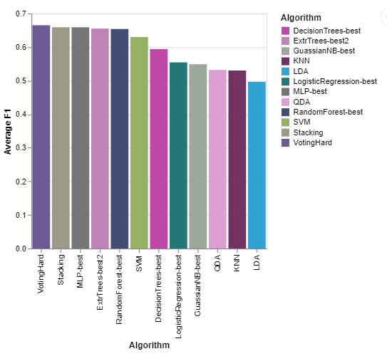
  Model | F1_Avg
  VotingHard | 66.50%
  Stacking | 65.91%
  MLP | 65.90%
  Extra Trees | 65.52%
  RandomForest | 65.39%
  SVM | 63.01%
  DecisionTrees | 59.41%
  LogisticRegression | 55.44%
  GuassianNB | 54.90%
  QDA | 53.19%
  KNN | 53.02%
  LDA | 49.64%

Upon examining the best results of every model in Table10 below along with the barchart, we deduce that the best model is the Voting Hard model that uses Decision Trees, SVM, Random Forest and MLP, followed by Stacking (same models), MLP, Extra Trees and Random Forest. These models have very similar results in the validation set ranging from 65.5% to 66.5%. Then, there are 7 models following with a decreasing F1. We conclude that the nature of our task is not an easy and linear separable task, since all the simple models have the worst results, while the best, are ensemble methods combining predictors and Neural Networks.

6. Final selected model
The final selected model is the Hard Voting Ensemble containing Decision Trees, Random Forest, SVC and MLP models. After training it on both training and validation sets, we tested it on the test data and the final Accuracy is 65.8% and the F1 score is 67.4%. In the following table we can see the F1 score for each genre:

F1_dnb | F1_psytrance | F1_hardstyle | F1_techhouse | F1_techno
0.96183206 | 0.9133217 | 0.84802043 | 0.84646195 | 0.84508671
F1_trance | F1_trap | F1_Emo | F1_Dark Trap | F1_Underground Rap
0.81444992 | 0.78382148 | 0.70017637 | 0.53304904 | 0.47608927
F1_Hiphop | F1_RnB | F1_Rap | F1_Trap Metal
0.47125842 | 0.44412811 | 0.43959732 | 0.36050157
Table 11: F1 scores for each genre on the selected model

The genres with the best scores are: dnb and psytrance with over 90%. Then comes hardstyle, techhouse, techno, trance, trap over 78%, emo at 70% then Dark Trap, Underground Rap, Hiphop, RnB and Rap below 54% and finally Trap Metal at 36%.
These results are confirmed with PCA, where we can see great separation of the dnb genre and almost no separation of Trap Metal.

7. Scientific and personal conclusions
In this project we followed a machine learning process encompassing several crucial steps, namely data preprocessing, data visualization, model testing and selecting the best performing model. Following these steps allowed us to obtain a better understanding of the intricacies involved in a machine learning project. We used a real dataset containing songs from Spotify and our goal was to predict the genre of a provided song, having a lot of information about them, like liveliness, valence, key etc.

Observing the results we obtained, we can see how none of the models perform great. Having taken a closer look at previous works done by other authors and the results we obtained for the different models, we can conclude that these results are probably due to not being a clear separation between some of the classes presented in the target, but grouping these classes would have led to a loss of information. However some genres are predicted with a very high F1 (Table 10), while others were very low, in which not a clear separation of the classes and some irreducible noise could play a crucial role. We note that we have 14 different classes and the random selection of a genre for a song is around 7%, but we have an average F1 performance of 67.4% on the test set.

In conclusion, we managed to get hands-on experience of how a machine learning project would be developed in a real case scenario, allowing us to apply the knowledge and techniques learned during the lectures and the laboratories, and to research more in depth when those were not enough, enhancing our understanding of the subject.

8. Possible extensions and known limitations
There are a lot of techniques and models we did not test during this project, for example using a transformer (e.g. RoBERTa), or boosting techniques like Gradient Boosting from scikit-learn or XGBoost from a different library. Due to the separation for some of the classes not being clear, we could increase the amount of training data to capture the details to separate those classes, while also trying extra techniques to handle the imbalance.

One of the problems encountered during the fine tuning of the hyperparameters and the testing was the execution time for some cases being extremely large. With more available resources to shorten this time we could have tested more and further optimized our models.

Appendix

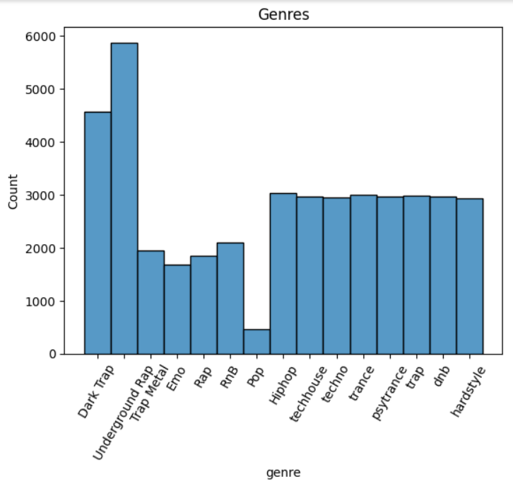
Figure 1: The distribution of observations along genres

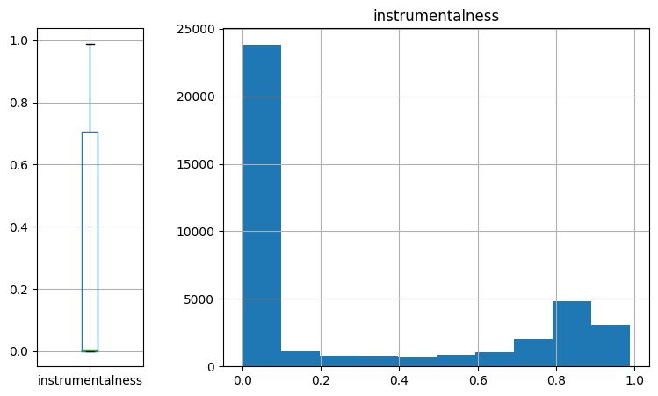
Figure 2: Boxplot and histogram of the instrumentalness feature

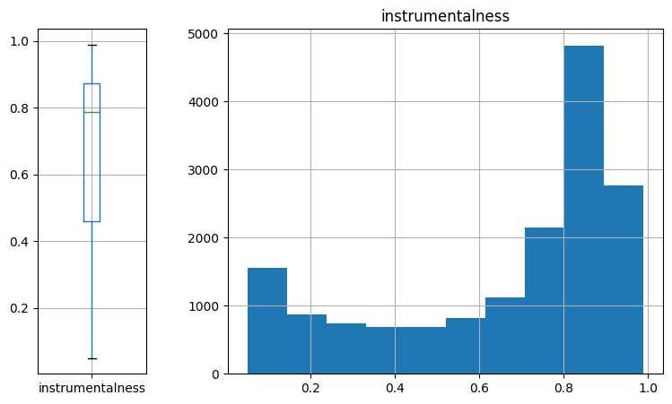
Figure 3: Boxplot and histogram of the instrumentalness feature above 0.05

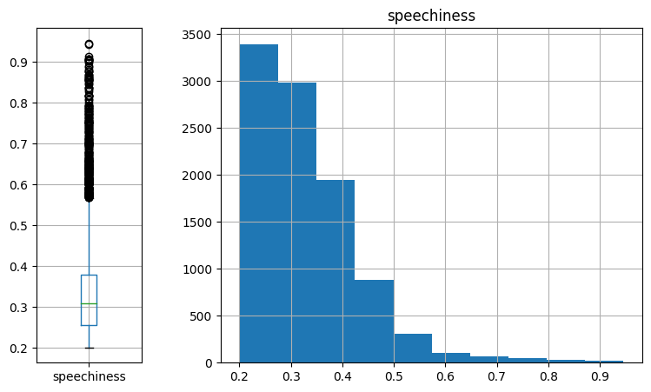
Figure 4: Boxplot and histogram of the speechiness feature
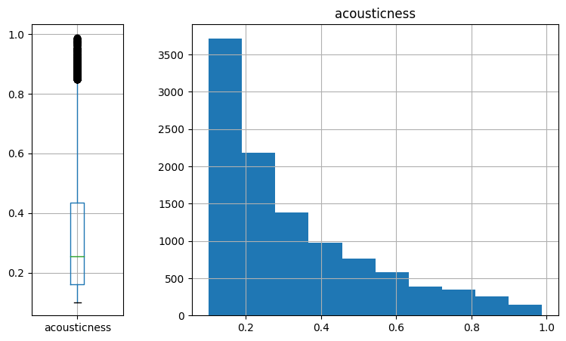
Figure 5: Boxplot and histogram of the accousticness feature
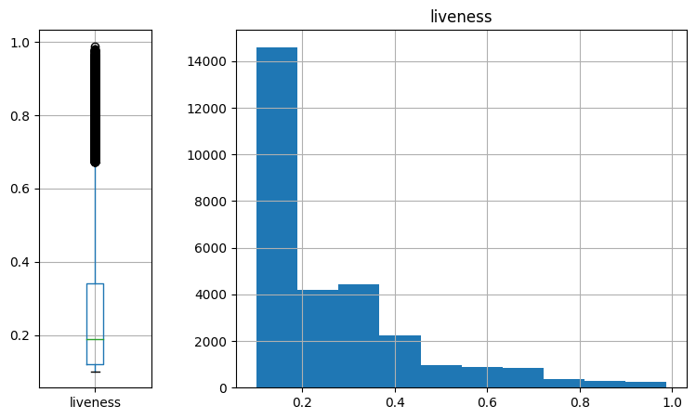
Figure 6: Boxplot and histogram of the liveness feature
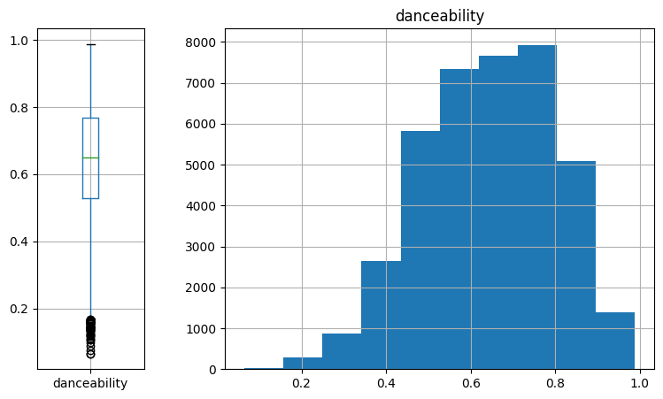
Figure 7: Boxplot and histogram of the danceability feature
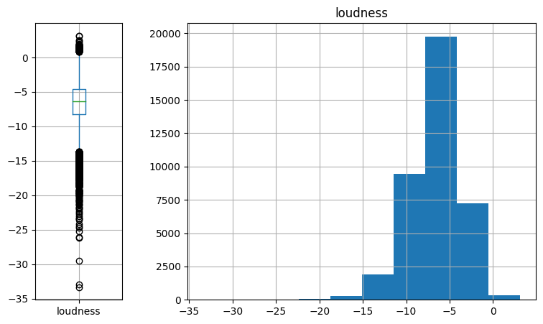
Figure 8: Boxplot and histogram of the loudness feature

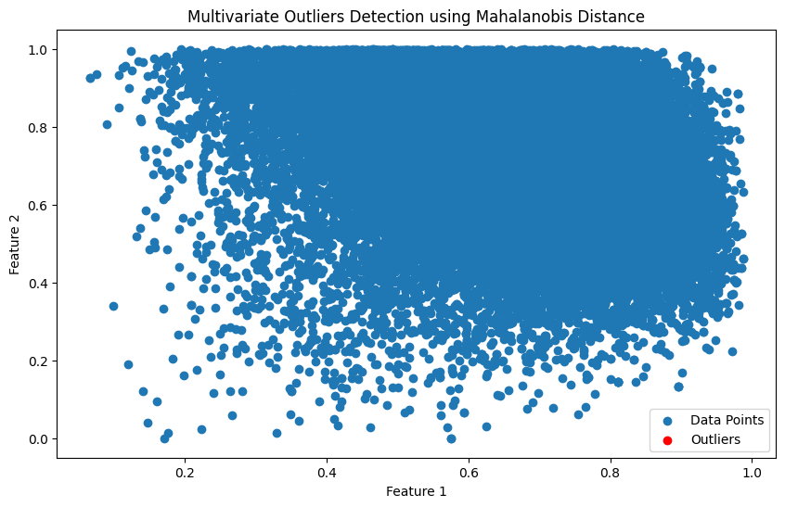
Figure 9: Mahalanobis distance values on the first two principal component axes
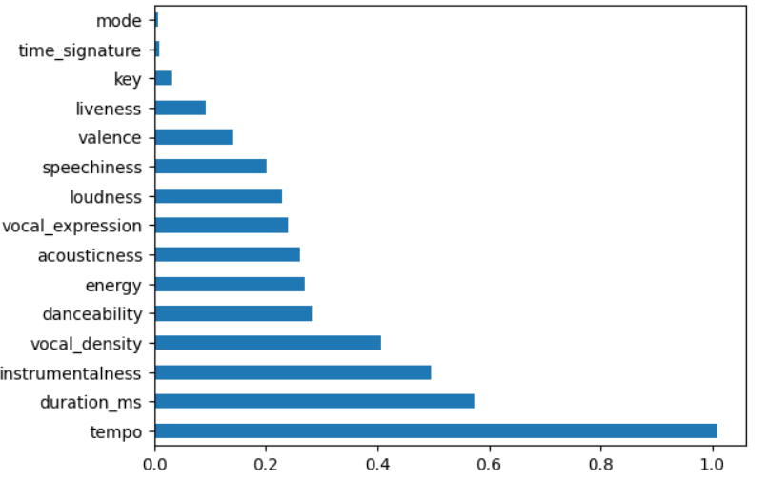
Figure 10: Feature Importance by Mutual Information
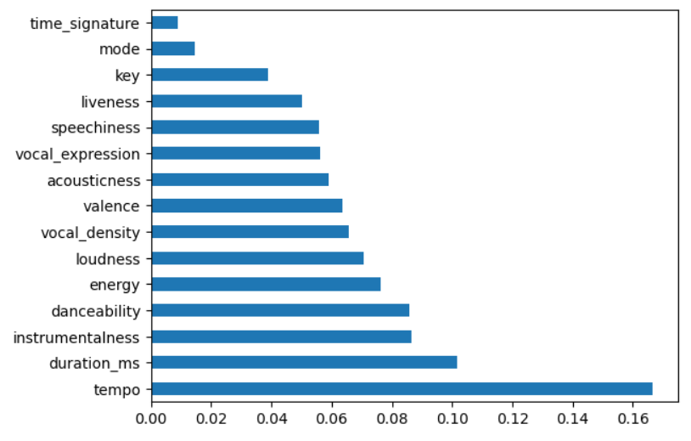
Figure 11: Feature Importance by Extra Trees
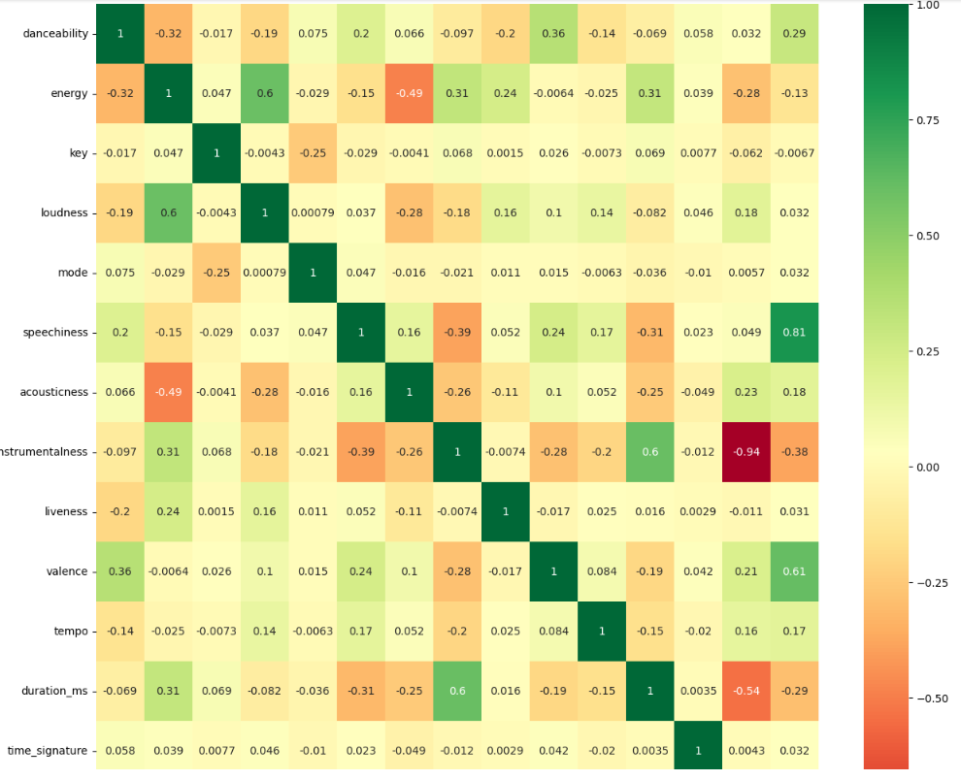
Figure 12: Correlation matrix between the features
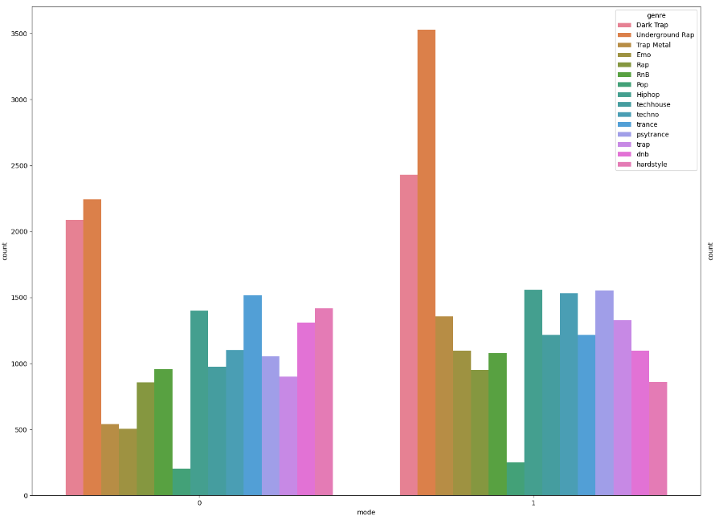
Figure 13: Distribution of Mode values along genres
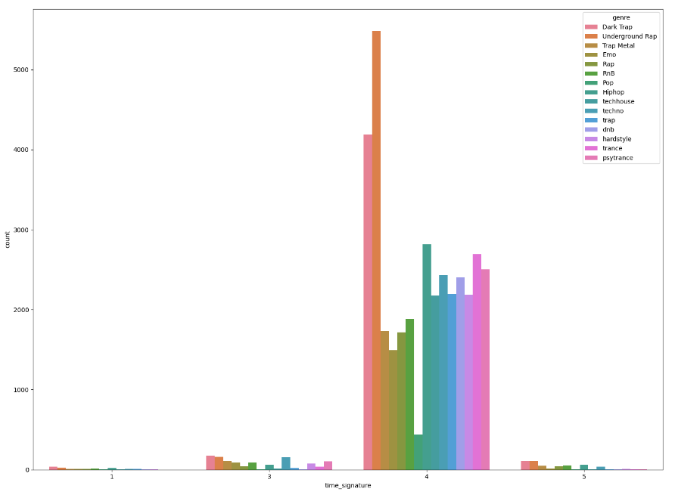
Figure 14: Distribution of Time signature values along genres

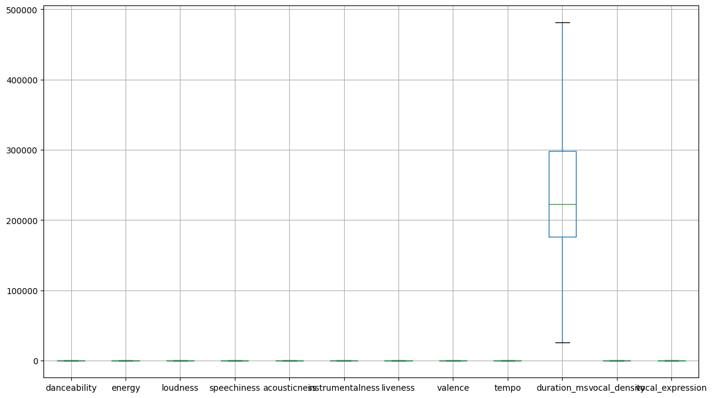
Figure 15: Ranges of values for the different variables before transformation.
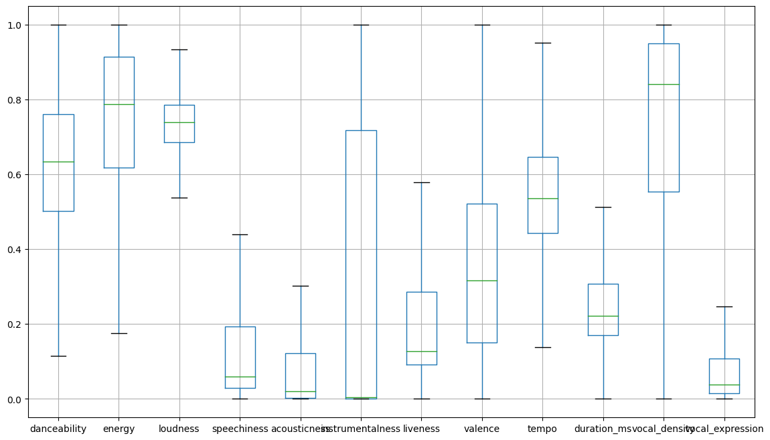
Figure 16: Ranges of values for the different variables after transformation.
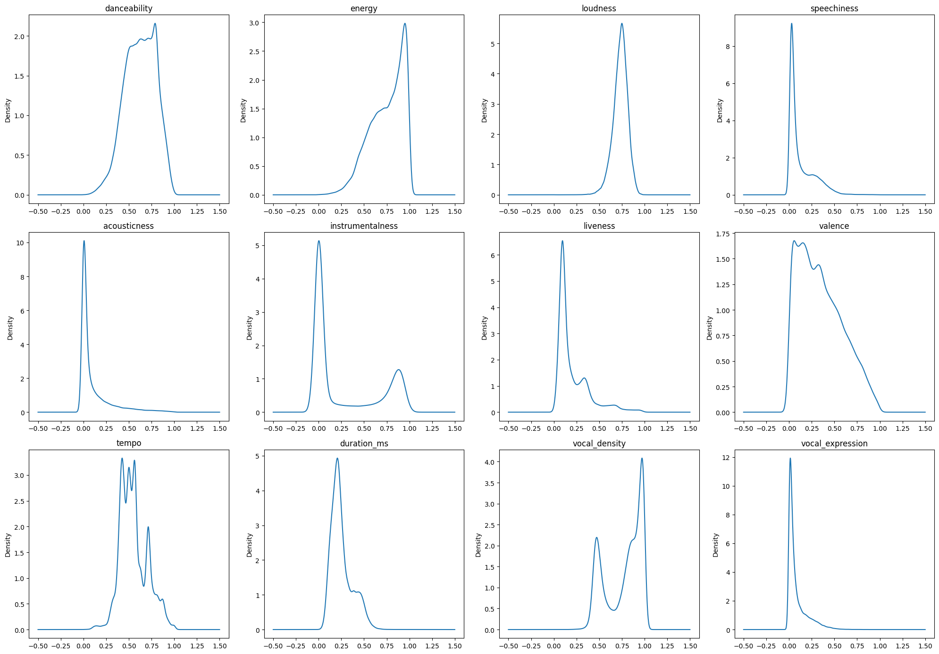
Figure 17: Data distribution of the different variables after transformation.
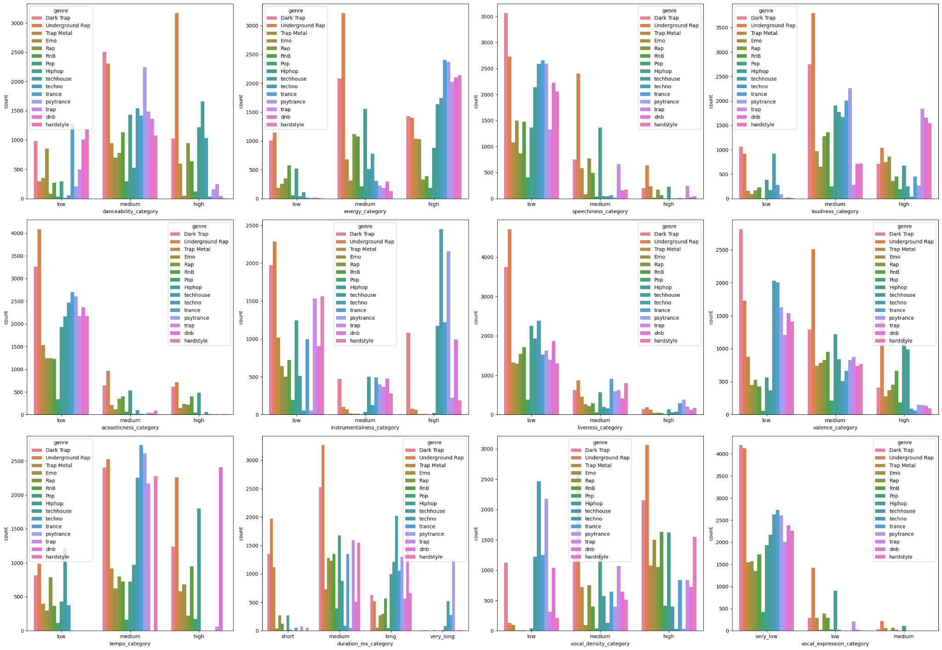
Figure 18: Distribution of the genre classes for the categorical transformation of each variable.
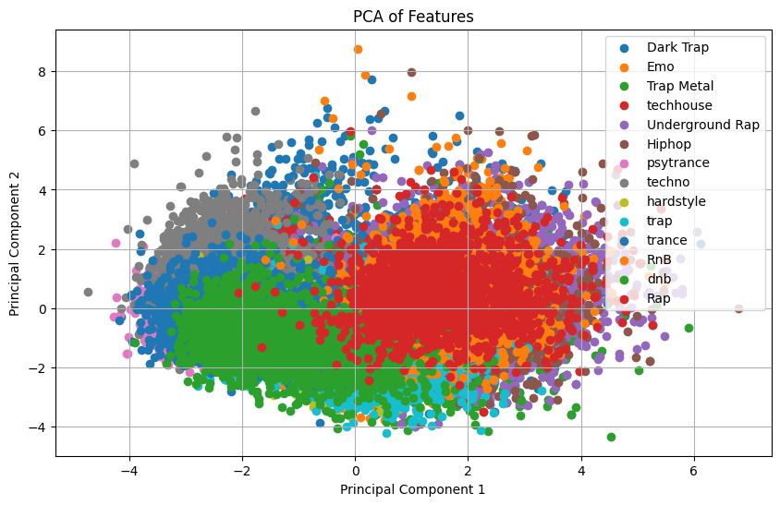
Figure 19: PCA with all genres

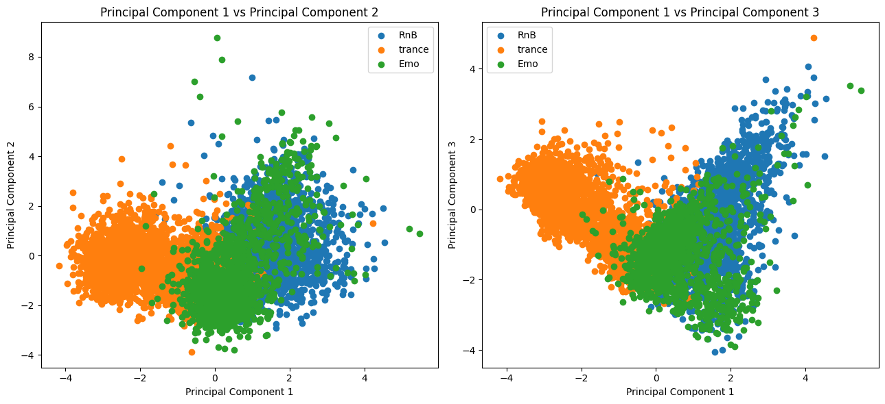
Figure 20: PCA with trance, RnB and Emo

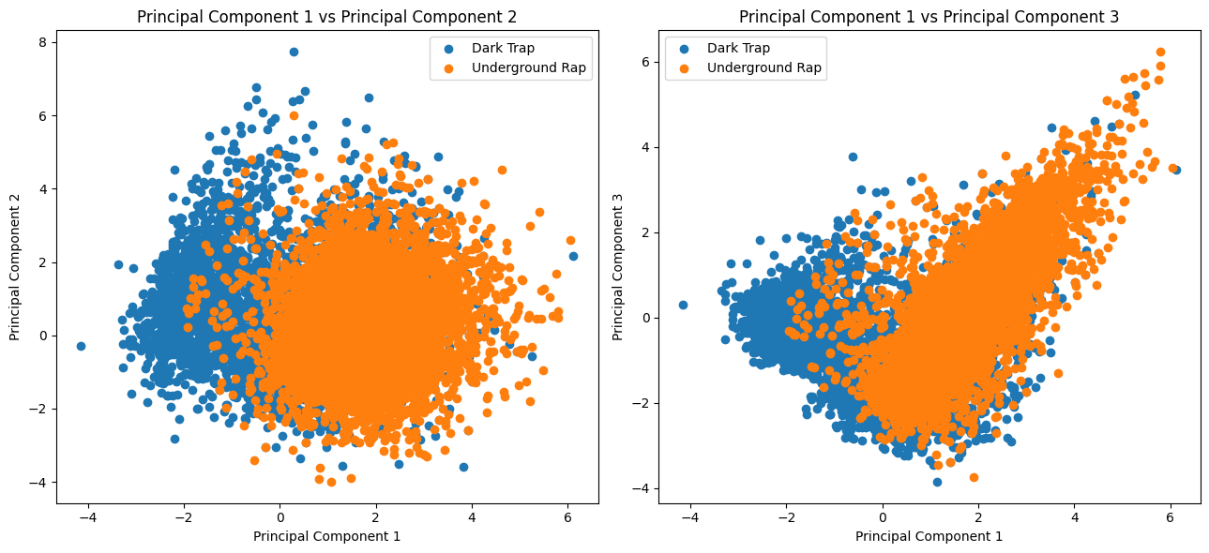
Figure 21: PCA with Dark Trap and Underground Rap

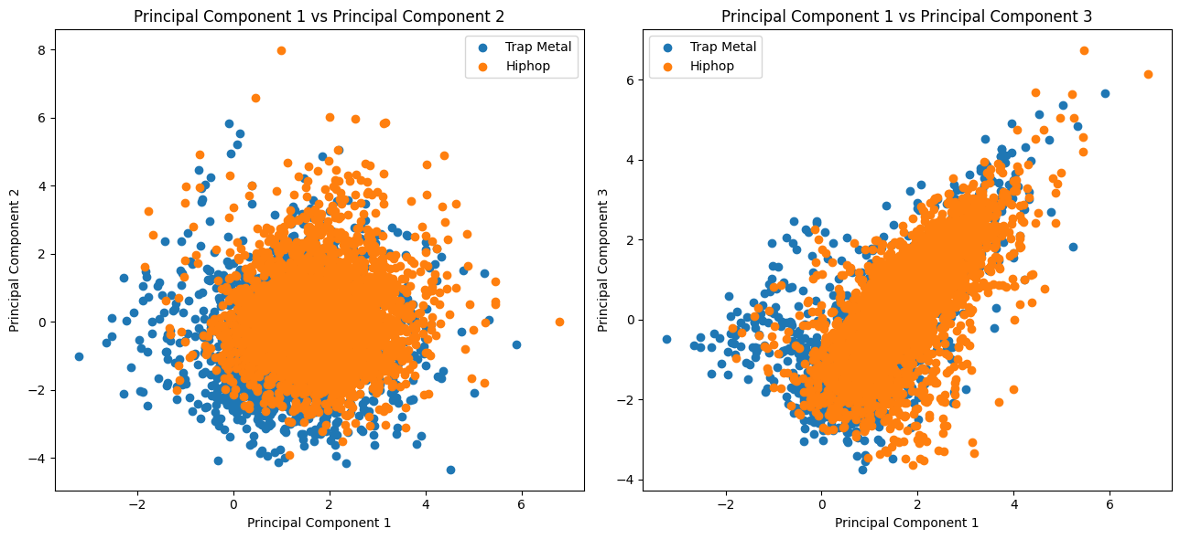
Figure 22: PCA with Trap Metal and Hiphop

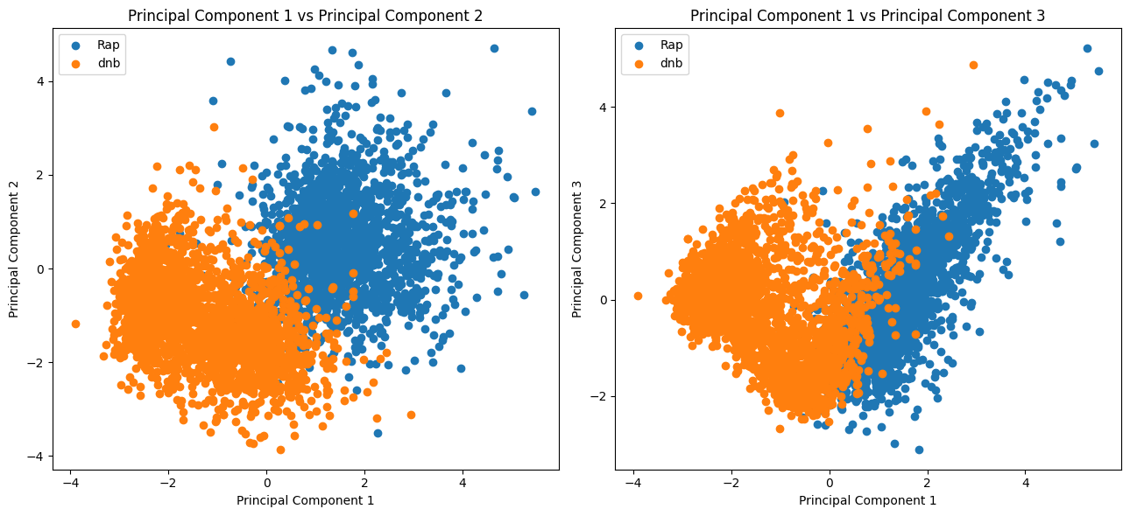
Figure 23: PCA with Rap and dnb

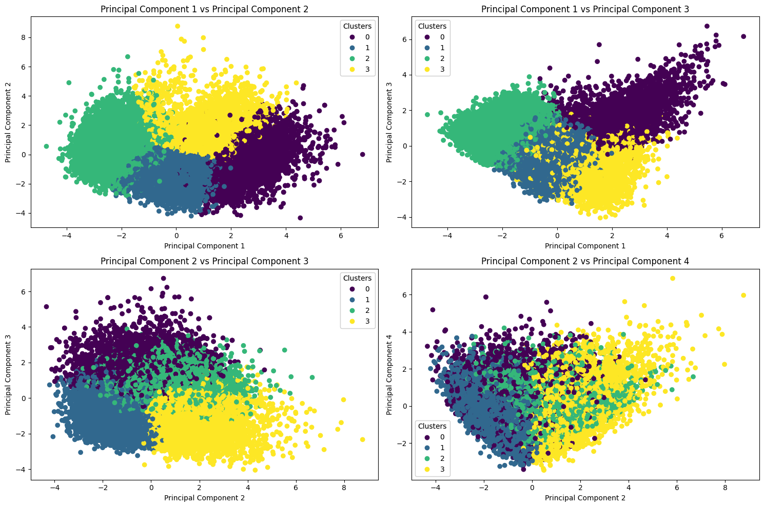
Figure 24: 4-means clustering on principal components

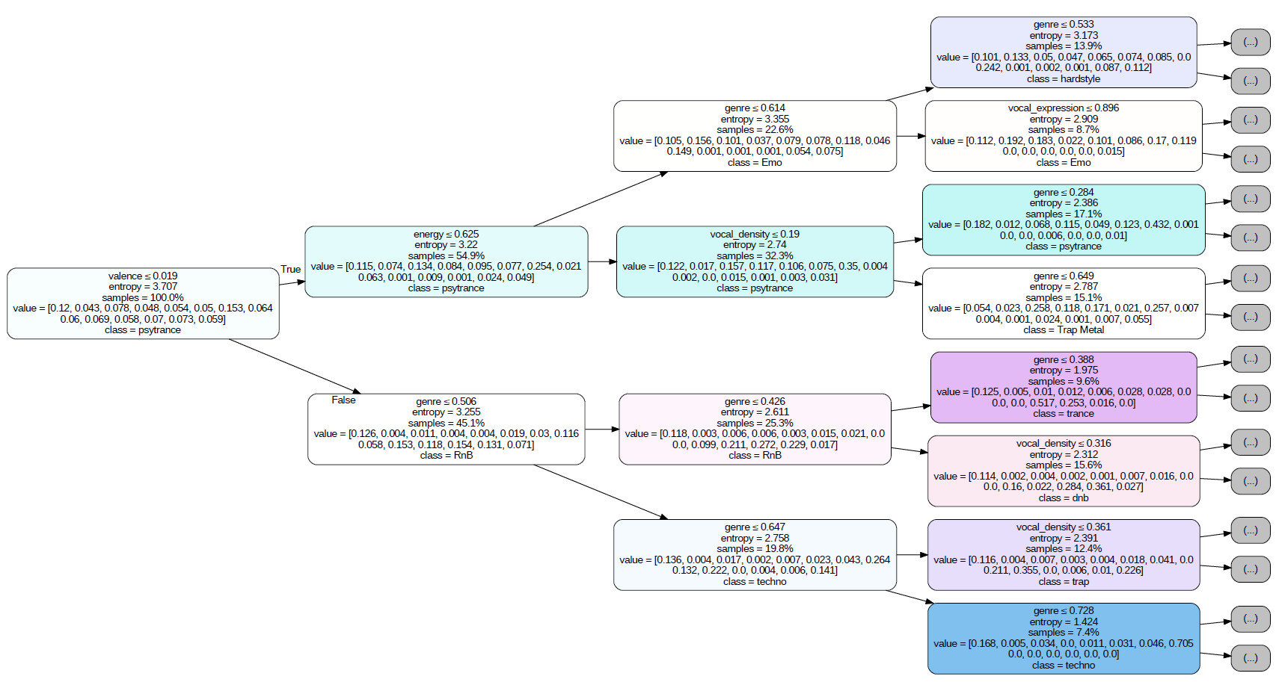
Figure 25: Visual representation of the decision tree with the best parameters.

References
[1] Gaussian Naive Bayes in Scikit-learn, https://scikit-learn.org/stable/modules/generated/sklearn.naive_bayes.GaussianNB.html
[2] LogisticRegression in Scikit-learn, https://scikit-learn.org/stable/modules/generated/sklearn.linear_model.LogisticRegression.html
[3] LinearDiscriminantAnalisys in Scikit-learn, https://scikit-learn.org/stable/modules/generated/sklearn.discriminant_analysis.LinearDiscriminantAnalysis.html
[4] QuadraticDiscriminantAnalisys in Scikit-learn, https://scikit-learn.org/stable/modules/generated/sklearn.discriminant_analysis.QuadraticDiscriminantAnalysis.html
[5] KNeighborsClassifier in Scikit-learn, https://scikit-learn.org/stable/modules/generated/sklearn.neighbors.KNeighborsClassifier.html
[6] DecisionTreeClassifier in Scikit-learn, https://scikit-learn.org/stable/modules/generated/sklearn.tree.DecisionTreeClassifier.html
[7] RandomForestClassifier in Scikit-learn, https://scikit-learn.org/stable/modules/generated/sklearn.ensemble.RandomForestClassifier.html
[8] What? When? How?: ExtraTrees Classifier, https://towardsdatascience.com/what-when-how-extratrees-classifier-c939f905851c
[9] SVC in Scikit-learn, https://scikit-learn.org/stable/modules/generated/sklearn.svm.SVC.html
[10] MLPClassifier in Scikit-learn, https://scikit-learn.org/stable/modules/generated/sklearn.neural_network.MLPClassifier.html

